**D1 – Evolving Output Mediums & their Impact on the Creation of Graphics**

Back when photography was first invented, and for nearly a hundred years afterwards, the only way to create images was analogue. The process was refined, but control over images was still limited to the skill of the photographer or editor, as everything was done by hand.  
Then, computers came along, and with them, the ability to display simple graphics. At first it was just text, then simple shapes, and at some point somebody figured out a way to make pictures by using lots of pixels to make up the whole picture.  
Soon, simple graphics editors were made, such as this example from the 80’s;

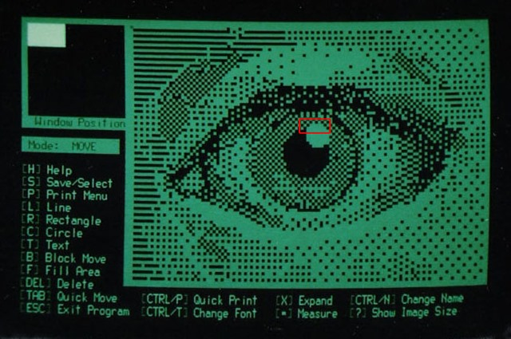

From then on, technology did what it does best – improved. The editors became more and more advanced, and colours became more accurate. First there was only 1-bit colour – the colour of the monitor or black. Then there were settings such as EGA, which had 64 colours.  
Eventually 24-bit colour, or ‘true colour’ was introduced. 24 bits can represent every colour that the human eye can distinguish, all 16 million of them. Nowadays we use 32-bit colour, as it is easy for computers to work with 32 bits than 24.

The hardware was improving throughout this time too. Early computers were less powerful than modern pocket calculators, but quickly improved. By the early 90’s, supercomputers were as powerful as the iPhone 4 is today – that is, they could 700 million calculations a second.  
The more powerful computers could handle higher resolutions and colour depths, so digital images became more and more realistic.  
One of the driving factors for this was computer games. People wanted games to look more realistic, and to have higher framerates. This meant the CPU (and later GPU) needed to render more complex images faster.

A modern powerful GPU, such as the NVidia 1080, can render a 4K image with dozens of effects such as ambient occlusion, motion blur, depth of field and ray casting upwards of 60 times a second (60 FPS). This means that even more middle-of-the-range graphics cards can now apply effects without any noticeable delay.

Nowadays the newest challenge is to get computers to create graphics themselves with as little human intervention as possible. Most games are a huge step forward in this respect – the designer simply creates a 3D space, and the game engine calculates what it looks like from any angle under different lighting conditions.  
More recently, Google created a neural network – an analogue ‘computer’ that works in a similar way to a biological brain – that can look at an image, find parts of it that look like other pictures, and seamlessly insert those other pictures into the original. The result are some strange looking images that are sometimes scary. It is called ‘Deep Dream’.

